##### Горизонтальная линия

**A-mazing Team**

Moscow

Game concept “Magic-fight”

**23 мая 2021 г.**

# DESCRIPTION

IO 3rd person game with bots on the stage with various obstacles.   
Auto strike area, free control.

# CORE MECHANICS

## Attack

Attack principle: **autoattack** (sktire to the area)

The strike has an zone - a circle / triangle with a radius of "X" meters (ex. 5-10 meters). Zone takes some space in front of player (ref in the end of topic “attack”).

In order to strike, you need to collect "power", randomly spawned on the stage.

The strike automatically occurs when:

* The player has stopped (does not move).

The strike will cause damage to the strike zone.

**Reference** to understand the mechanics of the strike zone and movement (control).

<https://appmagic.rocks/google-play/archero/com.habby.archero>

<https://www.youtube.com/watch?v=LjgutAcNXQo>

<https://play.google.com/store/apps/details?id=com.iqclash.crowdsmashers>

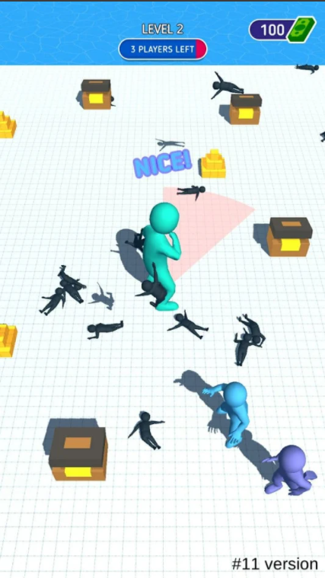

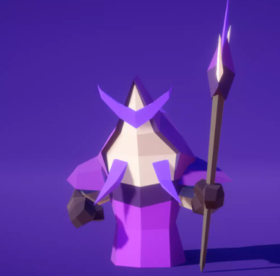

**Bots - RED**

<https://assetstore.unity.com/packages/3d/characters/humanoids/fantasy/mini-legion-lich-pbr-hp-polyart-91497>

**There are also animations of strike in this asset.**

**Player** - Green.

https://assetstore.unity.com/packages/3d/characters/humanoids/fantasy/mini-legion-lich-pbr-hp-polyart-91497

## 

## Movement

Controller type: drag to move (Joystick)

Basic movement config:

|  |  |
| --- | --- |
| Indicator | Value |
| Player movement speed | 2-3 m/s |
| Always run facing forward | YES |

**Reference** to understand the mechanics of the movement(control)

<https://appmagic.rocks/google-play/archero/com.habby.archero>

<https://www.youtube.com/watch?v=LjgutAcNXQo>

# TECHNICAL POINTS

**Camera and map - reference**

Testing options: circle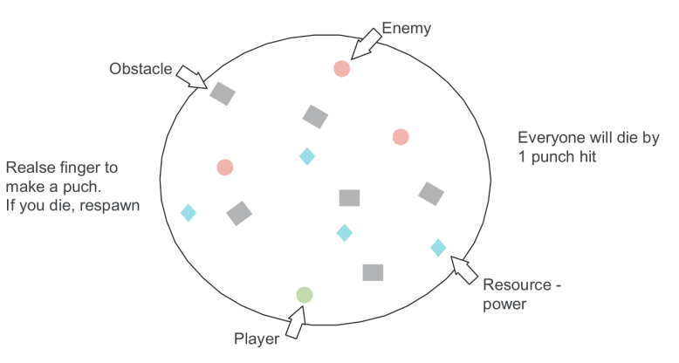

## 

## 

## 

## Art

Later

## Sounds

Later

## 

## 

## Config of other processes:

Permanent respawn after the death of both the player and the bots. Spawn after 3 seconds.

Maximum bots on the stage are 8.

Bots and player die from one hit.

The number of HP for bots:

|  |  |
| --- | --- |
| Bot Type | Number of HP |
| ordinary | 1 |

# KEY STEPS

## 1 iteration: prototype with core

We are introducing the core, we are looking at the playability with a different config.

Check-table

|  |  |
| --- | --- |
| The main parts of the project | Implementation at 1 iteration |
| Cor: strike | YES |
| Cor: movement | YES |
| Technical points: all | NO |

11111111

1111111111111